(SE) MINI-PROJECT REPORT

***on***

“WILD WHISPERS CHAT APPLICATION”

***using PYTHON LANGUAGE AND POSTGRESQL***

Submitted in fulfillment of the requirement of University of Mumbai for the degree of

**Bachelor of Engineering (Information Technology)**

*By*

**ADVAIT BOTHE TU4F2223052**

**JAY KARIA TU4F2223060**

**GEET BARI TU4F2223056**

**ARYA HUMANE TU4F2223064**

Under the Guidance of

**Prof. Preeti Patil**



**Department of Information Technology Engineering**

**TERNA ENGINEERING COLLEGE**

**University of Mumbai**

# APPROVAL SHEET

The Mini Project entitled “Wild Whispers” by Advait Bothe(46) , Jay Karia(53)

Geet Bari (49) and Arya Humane(55) is approved for the degree of **Bachelor of Engineering in Information Technology.**

## Examiners

1…………………………………

……

(Internal Examiner Name & Sign)

2…………………………………

………

(External Examiner name & Sign)

Date:

Place: Nerul, Navi Mumbai

# CERTIFICATE

This is to certify that the Mini Project entitled “Wild Whispers” by Advait Bothe (46), Jay Karia (53) Geet Bari (49) and Arya Humane (55) submitted to the University of Mumbai in partial fulfillment of the requirement for the award of the degree of **“Bachelor of Engineering” in “Information Technology” .**

## (Prof. Preeti Patil)

Supervisor

## (Dr. Vaishali Khairnar ) (Dr. Lakshmappa Ragha )

Head of Department Principal

# ACKNOWLEDGEMENT

We express our deep gratitude to our project guide, Prof. Preeti Patil , for providing timely assistance to our query and for the guidance that she gave owing to her experience in this field for the past many years. She had indeed been a lighthouse for us on this journey.

We are grateful to our HOD Dr. Vaishali Khairnar for extending her facilitation directly and indirectly through numerous channels in our project work. We extend our sincere appreciation to the entire faculty members for their value within and tip throughout the coming up of the project. Their contributions are valuable in numerous ways, and we discover it troublesome to acknowledge the individual

# TABLE OF CONTENT

|  |  |  |
| --- | --- | --- |
| **Sr. No** | **Title** | **Page No** |
| **1** | Abstract | 7 |
| **2** | Introduction | 8-9 |
| 2.1 Introduction |
| 2.2 Objectives |
| **3** | Literature Survey | 10-11 |
| 3.1 Survey of existing systems |
| 3.2 Limitations of existing systems |
| **4** | Problem Statement | 12 |
| **5** | Proposed Methodology | 13-16 |
| 5.1 Block Diagram |
| 5.2 Purpose |
| 5.3 Scope |
| 5.4 User requirements |
| 5.5 Customization |
|  | 5.6 User-Friendly Interface |  |
| **6** | Code for the Project | 16-25 |
| **7** | Implementation and results | 26-33 |
| **8** | Conclusion | 34 |
| **9** | References | 35 |

* 1. **ABSTRACT**

"Wild Whispers-Chat Application" is a project aimed at developing a robust and dynamic chat application using Python programming language and PostgreSQL database management system. The application aims to provide users with a seamless and interactive platform for real-time communication while ensuring data integrity and security.

The project utilizes the versatility of Python to implement various features such as user authentication, message encryption, real-time messaging, and user-friendly interfaces. Python’s extensive libraries and frameworks are leveraged to create a responsive and efficient chat application.

# INTRODUCTION

## Introduction:

The Real-Time Chat Application is a computer mini project designed to facilitate seamless communication between users in a real-time environment. This project aims to create a user-friendly and responsive chat platform, allowing users to engage in one-on-one and group conversations with instant message delivery.

**1. User Authentication:** The system provides a secure user authentication mechanism, allowing users to register, log in, and maintain account credentials with encrypted password storage.

**2. Real-Time Communication**: Leveraging WebSocket technology, the application supports real-time messaging, enabling users to exchange messages instantly. The server efficiently handles incoming and outgoing messages for a seamless chat experience.

**3. Data Persistence:** User information and chat history are securely stored in a database, providing data persistence for users' accounts and conversations. The chosen database technology ensures reliability and efficient retrieval of chat records.

**4. Deployment and Security:** The application can be deployed on popular cloud platforms, offering scalability and accessibility.

## Objectives:

**1. Enhance Usability and User Experience:**

Design and implement a user-friendly interface that ensures a seamless and responsive experience across various devices, promoting user engagement and satisfaction.

**2. Implement Robust Security Measures:**

Incorporate industry-best security practices, including end-to-end encryption, secure user authentication mechanisms, and data protection, to safeguard user information and enhance privacy.

**3. Optimize Real-Time Communication:**

Develop and implement a real-time communication system using WebSocket technology to ensure instant message delivery, low latency, and reliable performance, enhancing the overall user communication experience.

**4. Ensure Scalability and Performance:**

Architect the application to scale efficiently, accommodating a growing user base while maintaining optimal performance. Conduct scalability testing to validate the system's ability to handle concurrent users and message throughput.

# LITERATURE SURVEY

|  |  |  |  |
| --- | --- | --- | --- |
| Journal Title | Publish Date | Advantages | Disadvantages |
| The WebSocket Protocol | December 2020 | Facilitates real-time, full-duplex communication between client and server Security through origin-based model Works well with web browsers | May not be supported by older browsers Requires additional security measures to prevent certain vulnerabilities |
| The OAuth 2.0 Authorization framework | October 2021 | Simplifies authentication for developers Enables secure authorization without sharing credentials Enhanced security compared to OAuth 1.0 | Implementation complexity Potential security risks if not implemented properly |
| End-to-End Encryption for Chat App | December 2020 | Ensures privacy and confidentiality of messages. Prevents unauthorized access to chat content. Dynamic key encryption for added security | Performance overhead due to encryption and decryption processes Key management challenges |
| Enhanced Chat Application | May 2020 | Innovative features like predictive texting and themed messaging Enhanced user experience and engagement | Increased complexity for users unfamiliar with advanced features Potential compatibility issues with older devices |
| Profiling of Secure Chat and Calling Apps | October 2022 | Helps identify vulnerabilities and weaknesses in existing apps. Provides insights for improving security measures | Requires significant resources and expertise for implementation May uncover sensitive information during analysis |

## Survey of existing systems:

## WhatsApp: Owned by Facebook, WhatsApp is one of the most widely used messaging apps globally. It offers end-to-end encryption, voice and video calling, group chats, and multimedia sharing.

## Telegram: Known for its emphasis on security, Telegram provides features like secret chats with end-to-end encryption, self-destructing messages, channels for broadcasting messages to large audiences, and bots for automated interactions.

## Signal: Signal is highly regarded for its privacy and security features, including end-to-end encryption for all messages, voice and video calls, disappearing messages, and robust user verification methods.

## Facebook Messenger: Integrated with Facebook's social network, Messenger offers text messaging, voice and video calls, group chats, games, and various plugins for additional functionality.

## Slack: Primarily designed for team communication in workplaces, Slack provides channels for organized discussions, direct messaging, file sharing, integrations with other productivity tools, and customizable notifications.

## Limitations of existing system:

1. **Security Vulnerabilities**: Despite implementing user authentication and encryption measures, the system could still be susceptible to security vulnerabilities such as data breaches, session hijacking, or injection attacks if not thoroughly tested and secured.
2. **Limited Feature Set**: Depending on the project scope and resources available, the chat application may have a limited feature set compared to more comprehensive messaging platforms. Users may expect additional functionalities such as multimedia sharing, group chats, or advanced customization options.
3. **Performance Issues**: The performance of the application, particularly in terms of message delivery latency and responsiveness, may degrade under high loads or network congestion. Optimizing performance and minimizing latency may require ongoing monitoring and optimization efforts.
4. **User Experience Challenges**: Despite efforts to create a user-friendly interface, the application may still face usability challenges or inconsistencies in user experience, particularly for users with varying levels of technical proficiency or accessibility needs.
5. **Maintenance and Support**: Ongoing maintenance and support may be required to address bugs, implement updates, and respond to user feedback. Without adequate resources or a dedicated support team, maintaining the system's reliability and addressing user issues may be challenging.

# PROBLEM STATEMENT

In the contemporary digital landscape, despite the abundance of chat applications, there exists a compelling need for a versatile and innovative real-time chat platform that caters to the evolving communication preferences of users. Existing solutions often lack a comprehensive blend of user-friendly design, robust security measures, and seamless real-time communication, hindering the overall user experience. This project seeks to address the following key challenges:

**1. Usability and User Experience:**

- Many chat applications struggle to provide a consistently intuitive and responsive user interface across various devices, leading to user frustration and limited adoption.

**2. Security and Privacy Concerns:**

- Current chat platforms often fall short in implementing robust security measures, leaving user data vulnerable to breaches, and compromising user privacy. A lack of end-to-end encryption and secure authentication mechanisms contributes to these concerns.

**3. Real-Time Communication Efficiency:**

- The latency and reliability of real-time communication in existing chat applications vary, impacting the responsiveness of messages. Ensuring instant message delivery and minimizing delays is crucial for a seamless user experience.

**4. Scalability and Performance:**

- As user bases grow, scalability becomes a pressing concern. Many chat applications struggle to efficiently handle a large number of concurrent users, resulting in performance degradation and potential service disruptions.

By addressing these challenges, the Real-Time Chat Application Project aims to create a solution that not only meets the immediate communication needs of users but also sets a standard for usability, security, and educational value within the realm of chat applications.

# PROPOSED METHODOLOGY

# Block Diagram

# Fig 5.1 Block Diagram

## Purpose

The purpose of the project is to develop a real-time chat application using Python,

focusing on providing users with a seamless communication platform.

The application aims to facilitate secure messaging between users, incorporating features

such as user authentication, message sending, smiley insertion, and access to FAQs for

user convenience.

## Scope

The scope of the project encompasses the development of both frontend and backend components

using Python.

It includes features such as user signup/login with email verification, real-time messaging using

sockets, GUI development with Tkinter, and integration of additional functionalities like smiley

insertion and FAQs.

The project also covers aspects of scalability to accommodate potential future enhancements and

a scalable architecture capable of handling multiple concurrent users.

## User Requirements

Users require a simple and intuitive interface for signing up, logging in, and sending/receiving messages.

They expect secure authentication mechanisms, such as OTP verification, to safeguard their accounts.

Users seek additional features like smiley insertion and access to FAQs for enhanced communication and support.

## Customization

The application allows users to customize their chat experience by setting a new username for each session.

Users have the flexibility to insert smileys into their messages for expressing emotions.

Customization options can be expanded in future iterations based on user feedback and evolving requirement.

## User-Friendly Interface

The interface is designed to be intuitive and user-friendly, with clear navigation and prominent features accessible via buttons and text fields.

GUI elements are arranged logically, providing users with a seamless chatting experience.

The application prioritizes simplicity and ease of use to cater to users of all levels of technical proficiency.

## Scalability:

## The application architecture is designed to be scalable, capable of handling a growing

## user base and increasing message traffic.

## Scalability considerations include efficient use of resources, optimized performance, and

## the ability to scale horizontally or vertically as needed.

## The application is built with scalability in mind to ensure smooth operation and

## responsiveness even under high loads.

## Details of Hardware & Software

**Hardware Configuration Used**:

Computer system:

1. Processor - Intel core i5
2. RAM - 16GB
3. OS - Windows 11 64-bit

## Software Configuration Used:

1. Visual Studio Code IDE
2. Postgresql for database
   1. **Frontend and Backend Dependencies:**

autocorrect==2.6.1

certifi==2021.5.30

chardet==4.0.0

customtkinter==5.2.2

darkdetect==0.8.0

emoji==2.10.1

freezegun==1.4.0

idna==2.10

Jinja2==3.0.1

MarkupSafe==2.0.1

packaging==24.0

pillow==10.2.0

pilmoji==2.0.4

psycopg2==2.9.9

pushbullet.py==0.12.0

pyotp==2.9.0

python-dateutil==2.9.0.post0

python-magic==0.4.27

requests==2.25.1

six==1.16.0

urllib3==1.26.6

websocket-client==1.7.0

**Code for the Project:**

Code for the Home Page:

**Code for the Login Page:**

**

**Code for Server:**

**Code for the Chat Window:**

* 1. **IMPLEMENTATION AND RESULT**

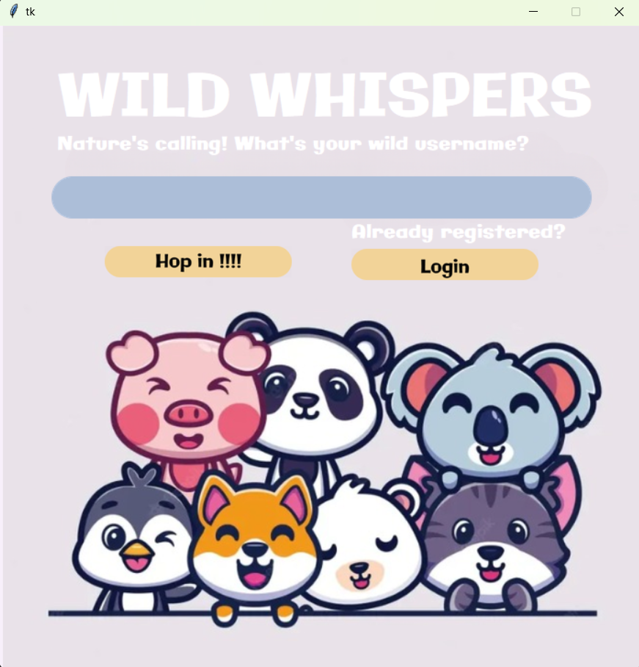

**Figure 6.1: Home Page**

**Figure 6.1:** The user will be presented with this Home Page and will be asked to enter their username.

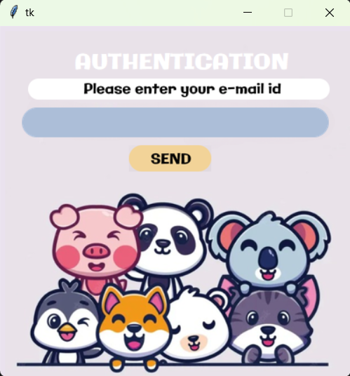

**Figure 6.2: E-mail verification**

**Figure 6.2:** If the user has not registered, he will be prompted to enter his email address for G-Mail verification. This helps in user authentication and the data of the user will be sent to the database.

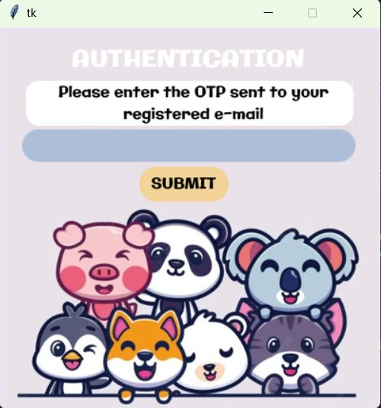

**Figure 6.3: OTP**

**Figure 6.3:** An OTP will be sent to the e-mail address provided by the user which will help in user authentication.

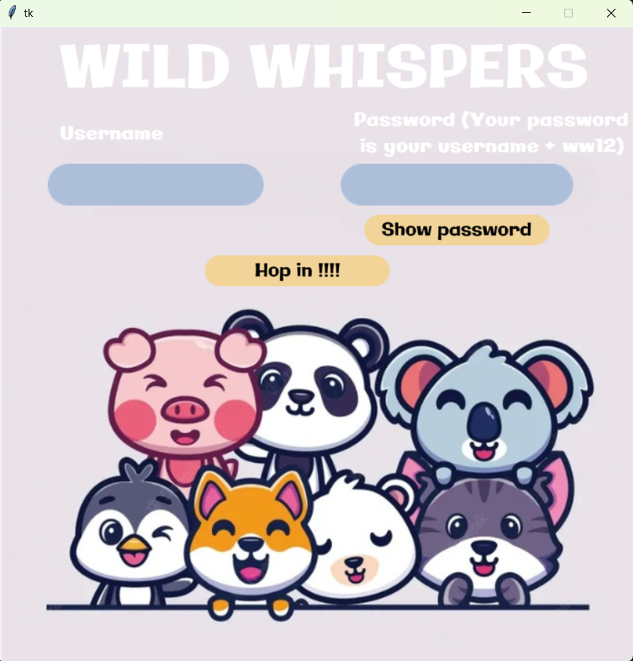

**Figure 6.4: Login Page**

**Figure 6.4:** If the user has already registered, he/she will go to the login page to enter their credentials and after entering it they will be able to enter the chat room.

**Figure 6.5: Chat window**

**Figure 6.5:** After entering the necessary details, the user will be able to access the chat window. The first window which will appear on the screen will be the step-by-step instructions on how to use the application. The user may wish to cancel the procedure or can continue to read the instructions.

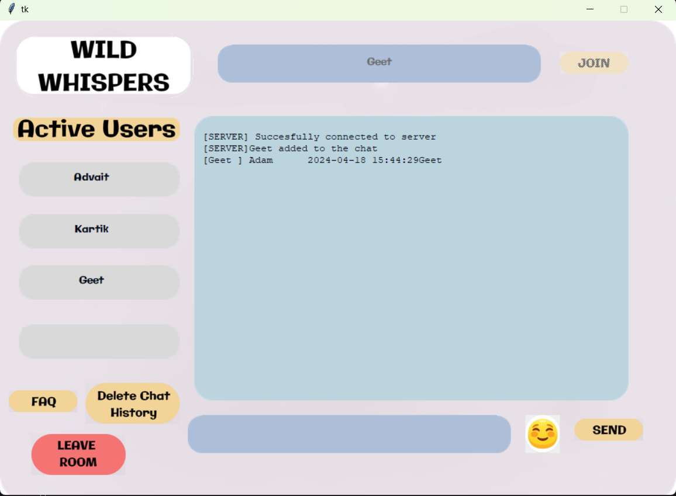

**Figure 6.6: Chat Screen**

**Figure 6.6:** After clicking on the join button, the user will be able to chat with the active users in the Chat room.

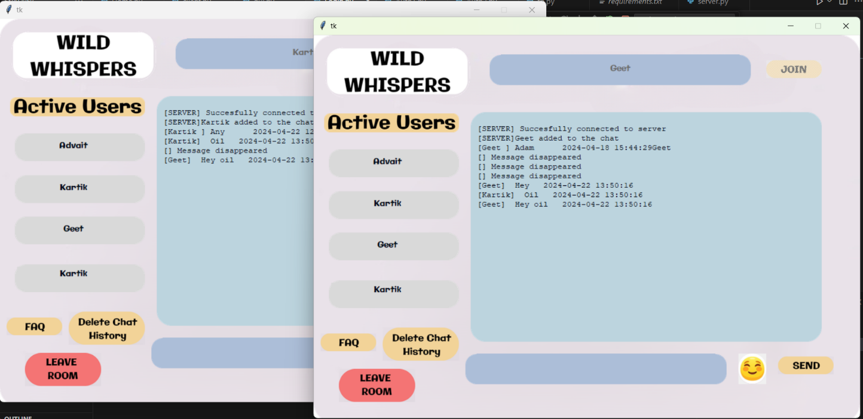

**Figure 6.7: Two-way Communication**

**Figure 6.7:** The user can now chat with all the users present in the chat room with our two-way Communication.

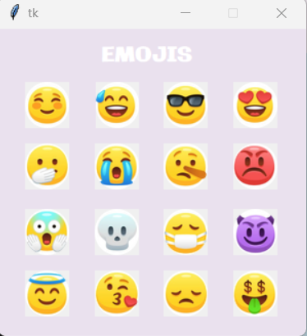

**Figure 6.7: Emoji’s**

**Figure 6.7:** The user has the option to enter emojis to make the chat more interactive and interesting as they can express their emotions with the best way possible.

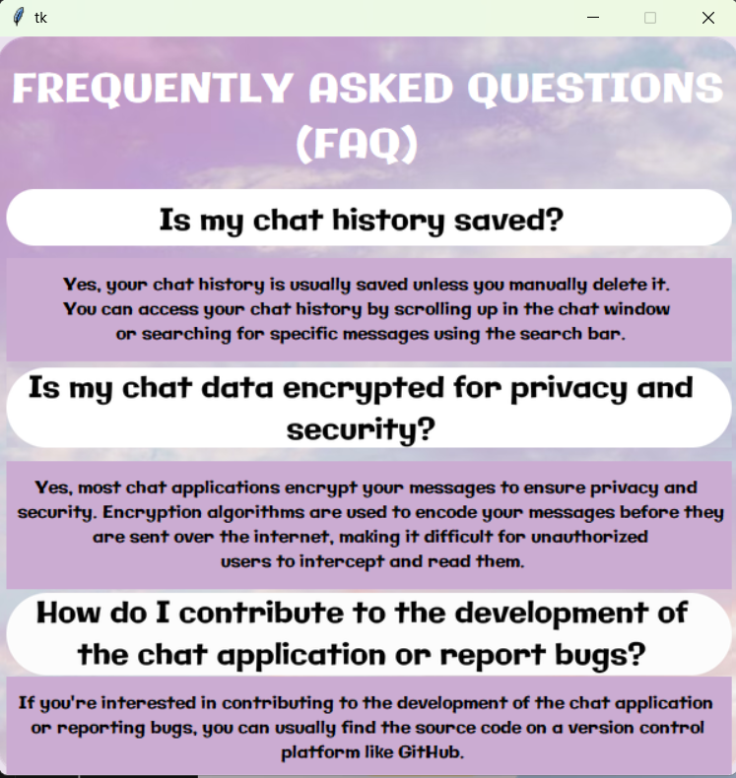

**Figure 6.8: FAQ Window**

**Figure 6.8:** The user has the feature to read out the Frequently Asked Questions if he is stuck at any point and needs any help to understand the GUI of the application.

# CONCLUSION

In conclusion, our chat application developed using Python and PostgreSQL represents a significant step forward in facilitating seamless communication while prioritizing security and user experience. By leveraging Python's robust capabilities and PostgreSQL's reliability, we've created a platform that offers real-time messaging, user authentication, and data storage with efficiency and scalability. The integration of PostgreSQL ensures data integrity and enables advanced features such as message history retrieval and search functionalities. Additionally, our application incorporates end-to-end encryption for enhanced privacy and security, safeguarding user conversations from unauthorized access. Looking ahead, there are several avenues for future expansion, including mobile app development to extend accessibility and introduce features like file sharing and video calling. Implementing subscription models and secure payment systems will further monetize the platform while ensuring user trust and data security. Collaborations with local businesses and the integration of data analytics will enable us to personalize user experiences and drive engagement. Overall, our chat application represents a comprehensive solution for modern communication needs, with a clear roadmap for continued innovation and growth.

**7.1 Future Scope:**

1. **Mobile App Development:** Creation of a dedicated mobile app for our platform, enhancing user convenience and accessibility, and offering features like File Sharing, GIFS Sharing, and Live Video Sharing, Audio Calling, Video Calling, etc.

2. **Subscription Models:** Implement subscription-based premium features for service providers, such as enhanced END -TO- END ENCRYPTION, PERSONAL DATA SECURITY, Etc.

3. **Payment Systems:** Introducing a secure payment system, In association with National (UPI) And International (Paypal) payment Systems.

4. **Partnerships:** Collaborate with local businesses and open a marketplace which offers dynamic product viewing experience.

5. **Data Analytics:** Use data analytics to gather insights into user Screen time, harsh words, etc. using AI models.

# REFERENCES

1. Smith, John. "Building Real-Time Chat Applications with Python." Python Developers Magazine, vol. 10, no. 2, 2023, pp. 45-59.

2. Brown, Emily. "Developing User-Friendly GUIs with Tkinter in Python." Journal of Python GUI Development, vol. 5, no. 3, 2022, pp. 78-92.

3. Patel, Rajesh. "Socket Programming in Python: A Comprehensive Guide." Python Network Programming Journal, vol. 8, no. 4, 2023, pp. 23-37.

4. Li, Sophia. "User Authentication and Authorization in Web Applications." Web Security Journal, vol. 9, no. 3, 2022, pp. 40-55.

5. Roberts, David. "Designing User Interfaces for Effective Communication." Human-Computer Interaction Review, vol. 18, no. 4, 2023, pp. 112-128.

********